OPERATION STARLITE (Revised & Updated)
Milo W. Plank, Jr.

I was the driver of A32 during OPERATION STARLITE. Our crew consisted of Cpl. Bill Laidlaw, (TC), L/Cpl. Court, (Gunner), Cpl. Milo Plank, (Driver) and Sgt. Dan McQueary, (Loader). Sgt.. McQueary, the Platoon Chief Mechanic, had been conscripted because Ken Zebal was on R&R. Alpha Company 3rd Platoon was attached to 3/3. For STARLITE that meant supporting 3/3 during the assault on An Cuong (1).

We embarked on LSD 16 (USS Cabildo) on the morning of Aug. 17 and headed east over the horizon. At H-Hour (0500) on D-Day (Aug 18) we were off shore near An Cuong 1 and made an uneventful landing.
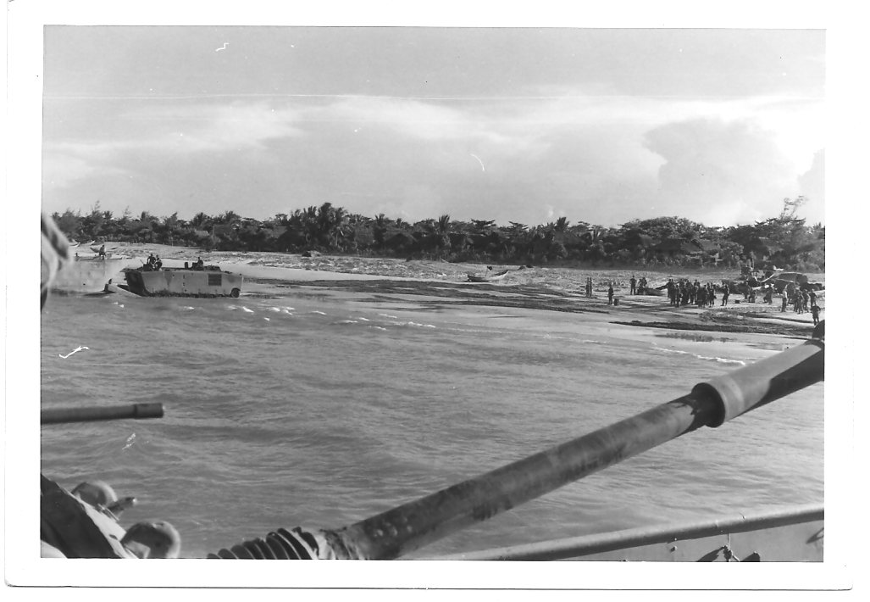
STARLITE Beach Landing

For this operation the Platoon was organized into two sections. The heavy section was A31 (Lt Thompson), A32 (Cpl. Laidlaw) and A34 (Sgt. Sipel). The light section was held in reserve at the Regimental CP and consisted of A33 (Cpl. Williams) and A35 (S/Sgt. Wilder). S/Sgt Joe Wilder was new in country and had recently been assigned as Plt Sgt because Sgt DJ Clark had rotated home.

The heavy section headed inland then turned north on line with I and H companies and met heavy resistance near An Cuong 2. On our right was a trench line running parallel to our line of advance. To our front was a trench line across our line of advance. A31 was in the center with A32 on the right and A34 on the left. As we were making a frontal assault across the meadow, we received close air support although I don’t remember if it was Navy or Marine aircraft and it was very impressive. The ordnance began impacting about 30 yards to the front and extended for about another 100 yards. Those jets were so low that Bill Laidlaw thought they were going to hit our antennas so he radioed Lt Ky Thompson about his concerns. Lt Thompson replied over the Platoon tactical net that the infantry didn’t seem to be very upset and that they didn’t have any steel protecting them.

Cpl. Robert O’Malley, a Squad Leader in India 3/3, with one of his four-man fire teams was on our Tank. When we approached the trench on our right flank, the enemy opened up with automatic weapons fire and the fire team all became casualties. A32 then moved to the edge of the trench to engage the enemy with our coaxial 30 caliber machinegun. There was thick brush growing up on both sides and we couldn’t see very far. The gunner (L/Cpl Court) traversed the gun to right and lowered it to fire. Then there was another burst of automatic weapons fire. One round hit the blast deflector causing it to ricochet up the gun barrel and wound Sgt. McQueary in the forearm. Two more rounds hit the searchlight. 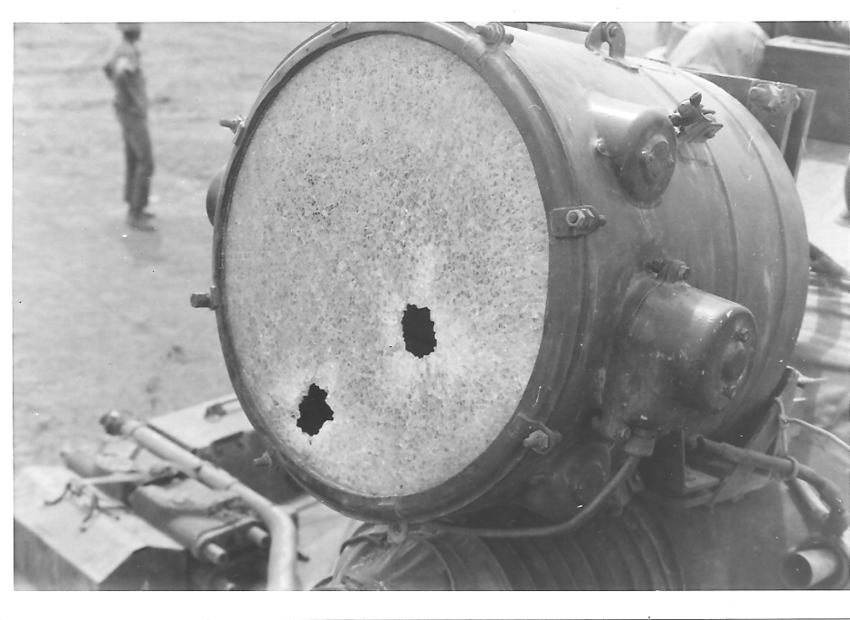
A32 Searchlight

A corpsman got into the turret and gave Sgt Mac first aid. When Sgt Mac was ready to be moved, I opened the driver’s hatch to get out and help get him down. However, I first looked out of the periscopes to see if it was safe. In my right periscope there was an opening in the brush and I could see a VC in the trench about five feet away pointing a rifle toward the top of the turret. As I raised up to fire my pistol the VC swung his rifle towards me. In trying to keep my head out of his line of fire I fired with my face too close to the 45 the slide hit me on the right eyebrow. I thought I had been shot. I put my hand on the wound, and didn’t find a hole so I knew it wasn’t my time to go.
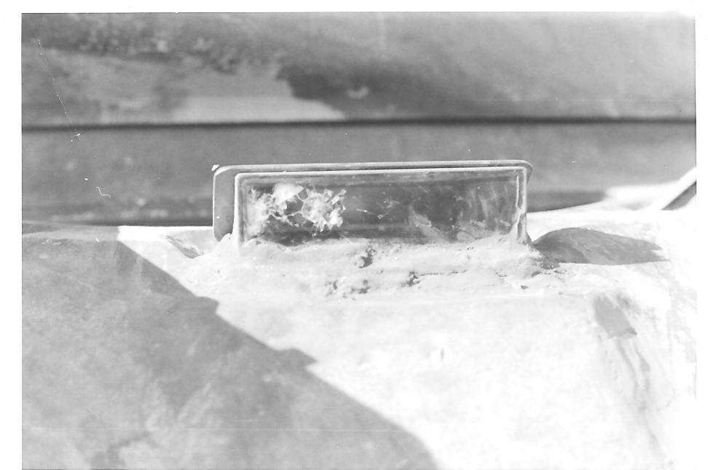
This periscope probably saved my life.

I could hear some movement in the trench, then more shooting. Several rounds hit my periscope which stopped the rounds from hitting me. There were M79 rounds being fired at the trench but they exploded in the brush and weren’t effective. I had a high angle of fire from the driver’s seat position and could fire down through the brush and thought I might be able to suppress their action. After quickly firing all 3 magazines of pistol ammunition I attempted get topside, but noticed a large number of VC coming down the trench and knew I couldn’t get out. Tit looked like the VC would soon be on our flank in force and be able to fire into our troops at point blank range. To my left, about ten feet away, Cpl. O’Malley was dressing the wounds of one of his men and saw me shooting, he turned my way and I shouted at him that the trench was full of gooks and were coming this way. Without any hesitation at all, he jumped right into the trench firing his weapon and as he moved out of sight, I could hear the explosion of grenades and rifle fire. I never thought I would see him alive again. I wasn’t going to get out of the tank without loading my weapon so I told L/Cpl. Court to throw me some 45 ammo. I got the ammo and reloaded my magazines just in time to see Cpl. O’Malley climbing out of the trench, his arms loaded with weapons. We loaded them onto the tank and then evacuated the casualties. Cpl. O’Malley received the Medal of Honor for his actions that day. 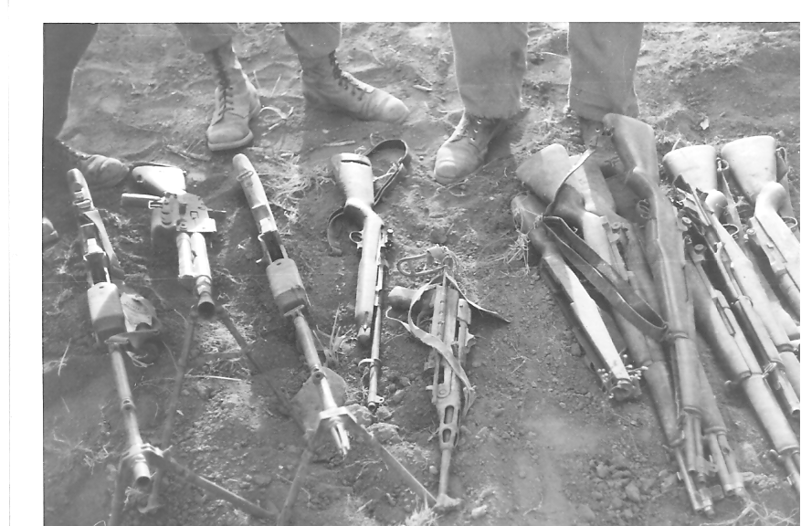
Weapons captured by Cpl. Bobby O’Malley.

A32 continued advancing to the front when A 34 was hit on the left side of the turret by a 75mm recoilless rifle round. The blast seemed like it wounded everybody on board. Sgt. Ed Sipel was severely wounded in the leg and, after having a tourniquet applied by Cpl. Jim Thompson, was evacuated. During the battle that day Jim Thompson sustained multiple shrapnel wounds and was evacuated to the USS Boxer later that day. The rest of the crew suffered minor wounds but the tank was still operational so A34 continued with the mission.
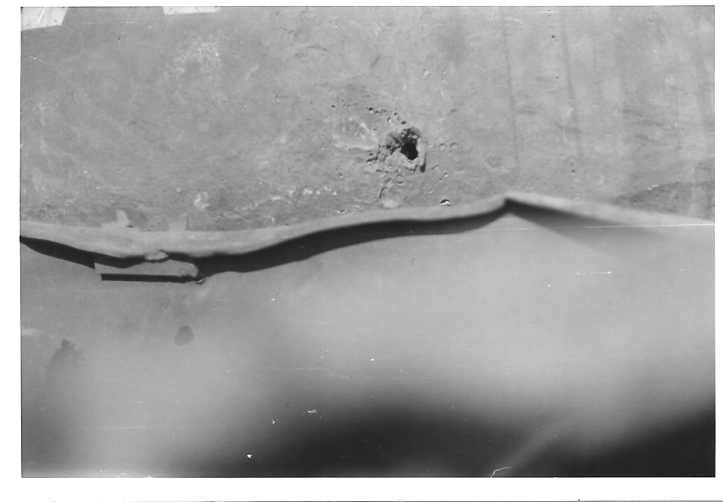
Hit on A-34 went through left side of turret and blew the fuse out of a WP round.
A31 was then hit on the right side in the turret ring. Its gun over the right side at 90 degrees and could not traverse. The penetration resulted in 2/Lt. Ky Thompson being wounded and he had to be evacuated. The rest of the crew also sustained wounds but the tank remained operational except that it couldn’t traverse the turret.

A 32 moved into a position to knock out the 75 recoilless-rifle, fired two rounds of WP of 90mm and destroyed it. We then shifted west only to meet heavy resistance near An Cuong ( 2 ). Either our radios or antennas were damaged but either way, we couldn’t get radio contact with A34. So we moved in close to them to communicate by voice. A different 75 hit the left rear corner of A34s engine compartment and penetrated the left fuel cell causing the tank to catch fire. It then had to be abandoned. Because A34 sustained multiple penetrations and burned up it was later destroyed in-place by Marine Combat Engineers.

Cpl. Bill Laidlaw was hit by shrapnel and killed. A34s driver, PFC Cunningham transferred to A 32 and A34s gunner, Cpl. J. B. Thompson transferred to A 31. The dead and wounded from our Platoon along with some from 3/3 were loaded onto the tanks and we returned to the medical evacuation area.
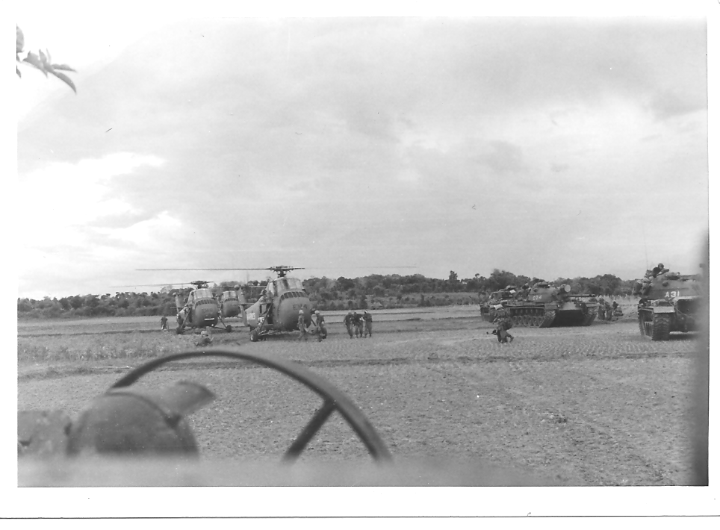
Tanks defending Medical Evacuation Area

Later that afternoon we got orders to proceed to Hill 43 and help secure it. A31 and A32 moved west and became lost. It was getting dark and we knew we were in big trouble if we didn’t make contact at Hill 43 soon. Our radios were damaged and periscopes shot up and A31 could not use its main gun or its coax. It became dark when we came upon some burning vehicles (Supply Column 21, five LVTs and two Flame Tanks). A31 somehow managed to make radio contact with Charlie 6, (Capt. Saunders), report the situation and ask for further instructions. He told us to stay put and defend our position as best as we could.
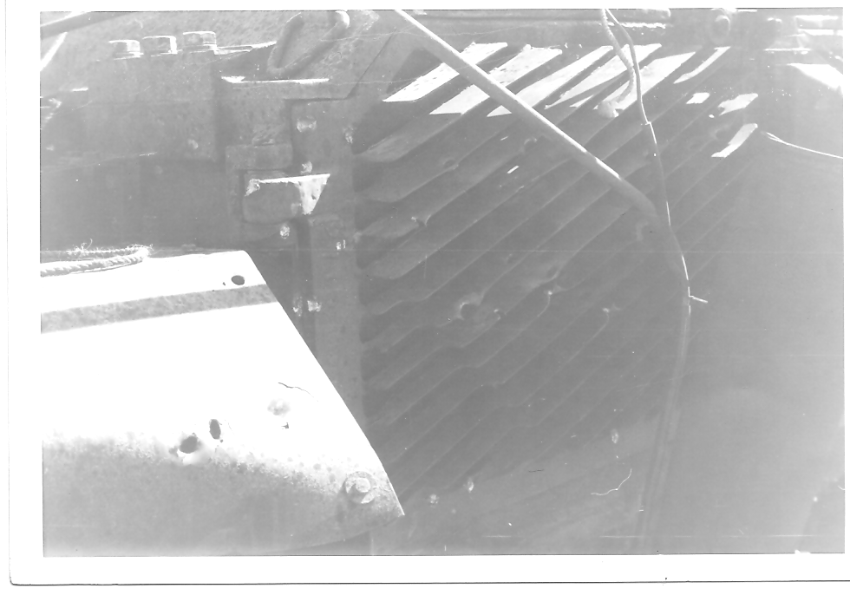
Flame Tank

Supply Column 21 made the same mistake we did earlier that afternoon and also became lost. They got into an ambush, faced extremely close fighting, suffered heavy casualties and could not escape. Two LVTs tried to escape by crossing the rice patty and got stuck. Even though they had radio contact they could not describe their exact position to the CP.
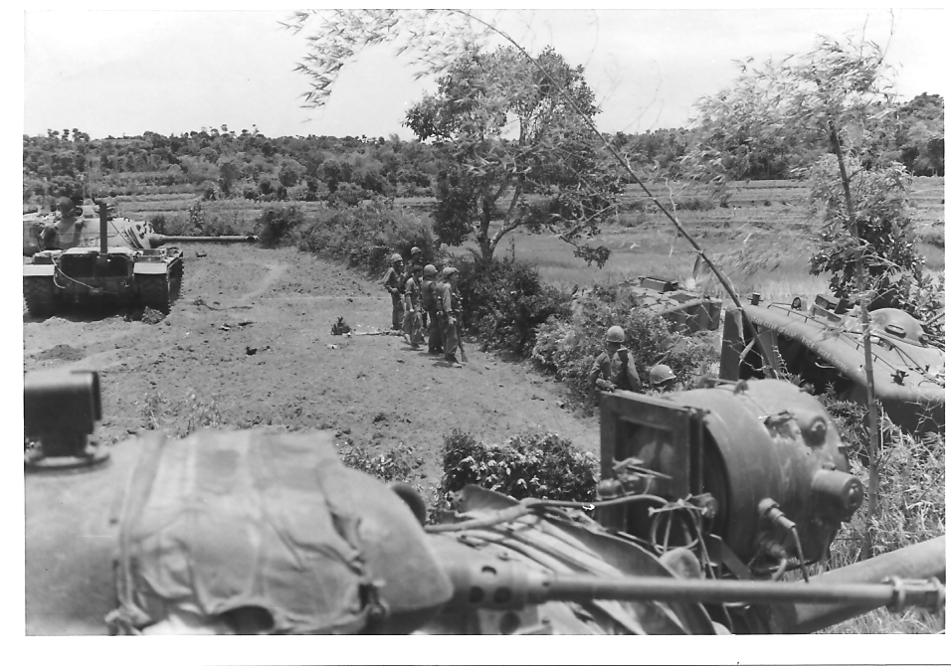
Supply column 21 ambush site.

It was now dark and the only light we had were the glowing hulks of burning vehicles. It was quite except for an LVT that sounded like a popcorn popper as the 30 ammo and the occasional whump of a grenade cooked off. We didn’t know if anyone was still alive but we had no other choice but to stay there and wait for daylight and be ready to fight for our lives.

A shadow moved in front of my driver’s periscope and my first thought was that we were in for a satchel charge attack right on my drivers hatch. I was about to open the hatch and start shooting when a voice asked if we had any more room in there? I could see that it was a Marine and said we will make room. He climbed on top of the tank and dropped down through the loaders hatch. He told us that he was an LVT crewman and had been wounded and had been playing dead. It was about 110 degrees (and humid) out there and he didn’t have any water left. We had very little but shared what we had.
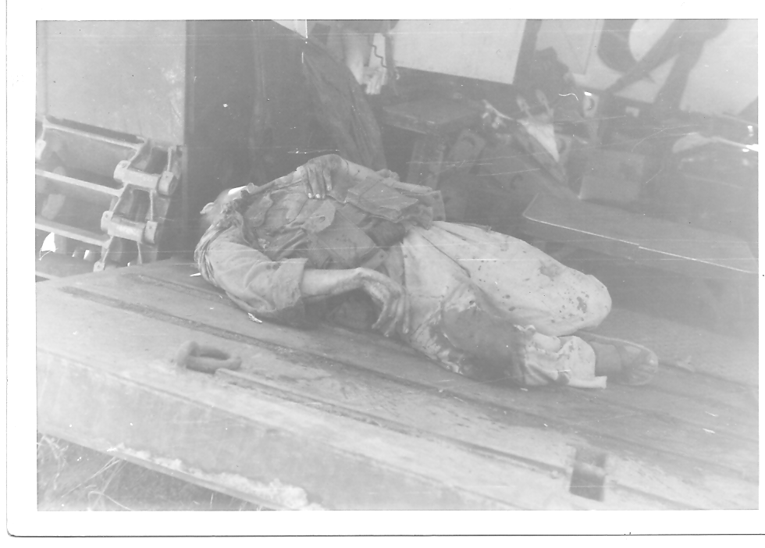
This attacker was shot off the top of this LVT

At about 0100 we became extremely dehydrated. If we didn’t get some water we wouldn’t last till morning. At the time we had two five-gallon cans of water strapped to the side of the turret next to the loaders hatch so I decided to go out and get one. The flickering light of the burning vehicles was not enough to illuminate me so I proceeded to go unstrap them. They were both shot full of holes but one had about a gallon left in it so I handed it down the loaders hatch. That small amount didn’t last very long so I decided to find another can. The LVT crewman said that the AMTRAC directly across the clearing from us with the ramp down had a full store of water. If anyone was going to get some water, they’d better do it before daylight or else be an easy shot for a sniper. At about 0400 I quietly got out of A32 and walked the twenty-five yards across the opening and, stepping over some bodies, made it inside the LVT. I was initially going to carry two cans but then decided on only one because I wanted to carry my 45 in my free hand.

As daylight approached all was quiet and people began to stir. The remaining Marines came out of their vehicles and set up a defensive perimeter. Then on August 19th at about 1000 the rescue force arrived.
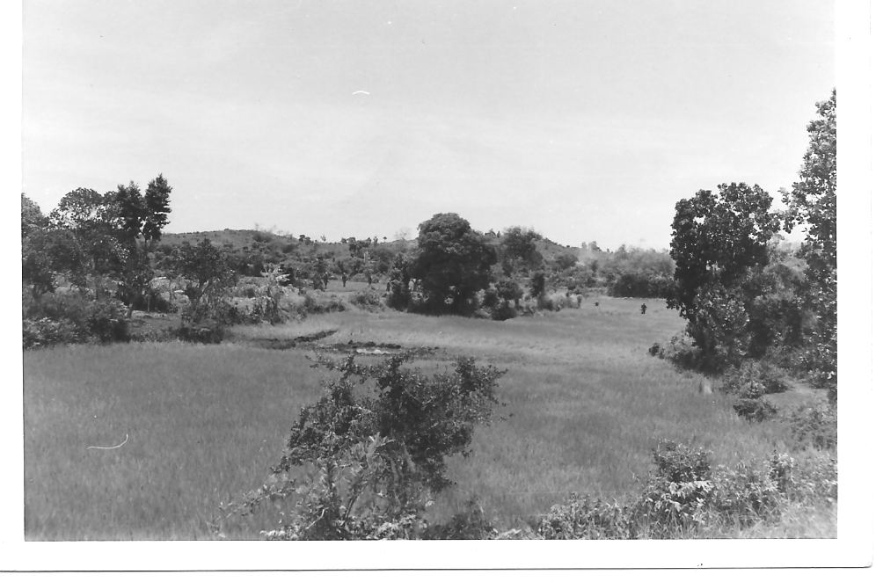
Reinforcements arrive

We stayed at the Regimental command post till August 25th when OPERATION STARLITE ended on 25 and our three tanks backloaded each onto a separate LCU late that afternoon in preparation for the 10-mile trip north back to Chu Lai. The plan was to cruise north, secure the LCU to the floating causeways end, drop the ramp and then slowly off-load onto the causeway and carefully drive to the beach – at night, in the rain with heavy seas.

As one might imagine there was a huge amount of equipment lined up and everyone was waiting their turn to off-load. About that time the wind began to pick up which resulted in only one tank at a time being allowed on that 200-yard long floating causeway. This slowed the off-loading process considerably but also made it safer. At or about 2300 our turn finally came but by that time the wind was up even more, it was very dark and the causeway began to really rock and roll.

I was driving A-32 and L/Cpl. Court was ground guiding. I felt that we’d be okay if we made it ashore quickly, however, it was very slow going and the waves were now slamming up against the causeway sides and washing over the deck which made it slippery. L/Cpl Court was getting soaked and so was I. Although it weighed 52 tons the tank began slowly sliding left after each large wave crashed over the causeway which, in turn, caused the causeway to list until I slowly and carefully maneuvered the tank back to the center again, and again.

L/Cpl Court was so exhausted that he could barely stand on his feet. After slowly inching our way forward for well over an hour we finally made it to the beach and then drove to the 3/3 CP and our Platoon CP.

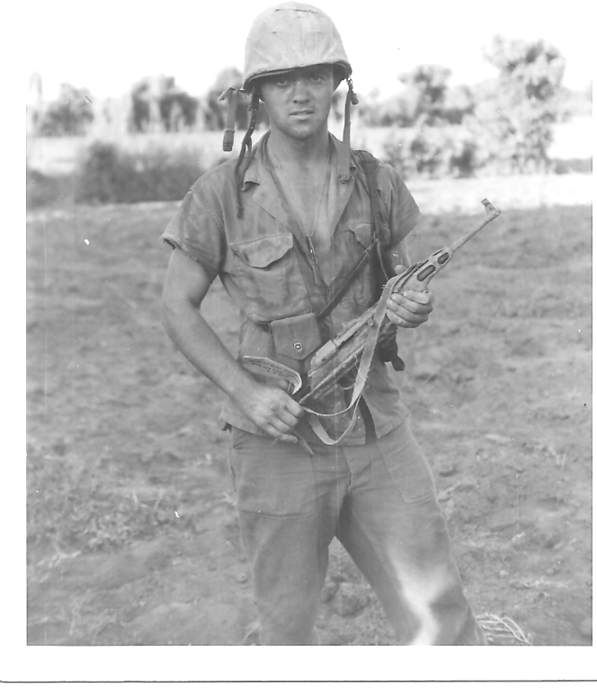
Cpl. Milo W. Plank, Jr.

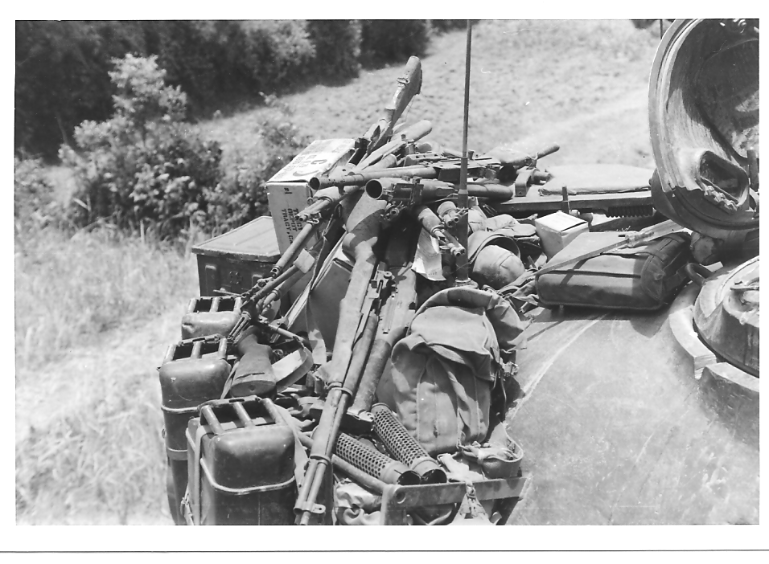
Captured weapons and 75 recoilless cases.

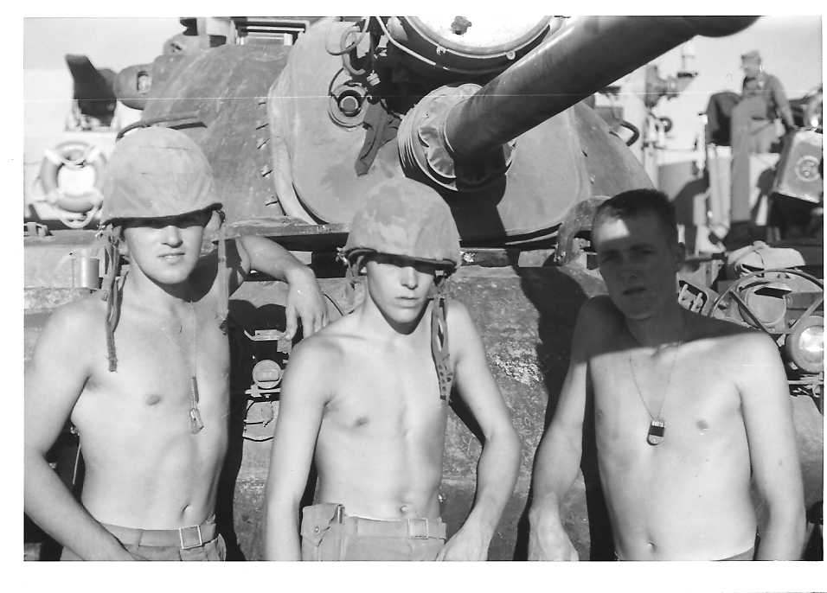
Left to right; Cpl. Milo Plank, PFC Cunningham, L/Cpl. Court
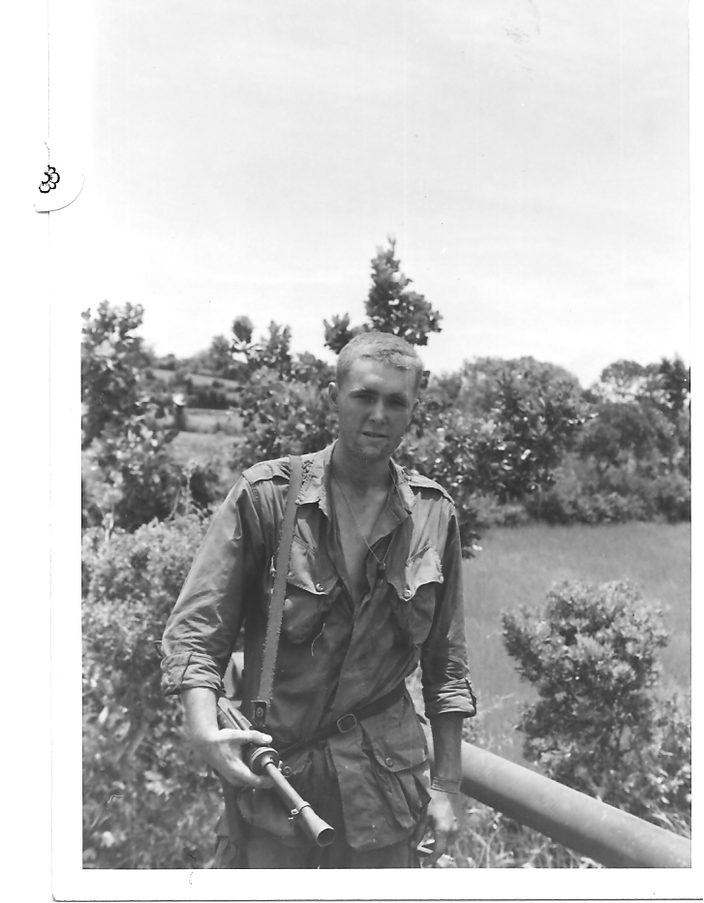
L/Cpl. Court with M3A1 Grease Gun

