SPECIAL ANNOUNCEMENT

2024 Mini-Reunion – We are going to (again) visit Columbus, Georgia in September 2024.

We have been invited to visit a brand new (and yet not open to the public) Tank Collection at Ft Benning (aka Fort Moore). If you remember, back in 2018, we conducted our first (ever) mini-reunion where we visited the (now closed) USMC Tank School and a very special Tank Restoration Project located at Ft Benning. While we were there, we learned that the Tank Restoration Project was being conducted with the idea that the US Army would eventually open a massive and all-inclusive Armor Museum. Many of the tanks have now been fully restored and are housed in a very large building on the Army base.

One very interesting point was the fact that the Tank Restoration Project has at least one of every tank that was ever produced at any time, by any nation in the world. The one and only exception is a tank that was produced by the Nazi during WW-2 which is the super-heavy “Panzer VIII Maus” tank. We understand that only five of those German monster tanks were ever produced and only one survived after the war. That one and only model is now housed in the Russian Tank Museum in Kubinka.

Next September when we visit Ft Moore, we will see a very impressive collection of international armored vehicles. Another interesting note is that the M-4 Sherman tank had 19 variants built over the years. The collection will have one of each variant. Below is a photo images of some of the restored tanks.

The mini-reunion hotel will be the Hampton Inn (2870 Lumpkin Road, Columbus, GA 31903) where we stayed in 2018. The dates for our gathering are September 12 – 15, 2024. The special hotel room rate is $139+ tax per night with a free breakfast each morning.

More details and more photos are on the last three pages of this issue.

U.S. Army Armor & Cavalry Collection

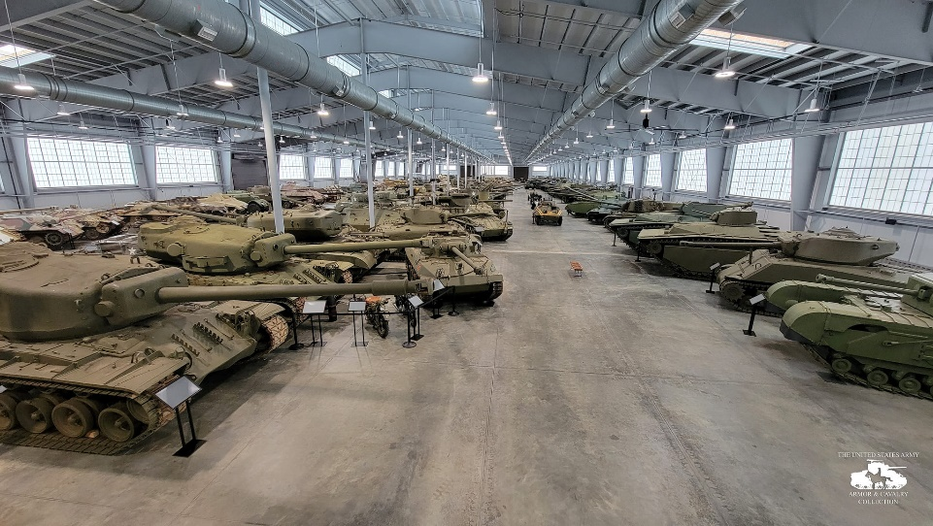

Please note: When you make the decision to join us in Columbus, you will need to fill out a 2024 USMC VTA Mini-reunion Registation form, write a check for $25 for each attendee and mail it to the return address on the form. That new registgration form is included in the last three pages of this issue of our magazine.

