First Section

2022 Mini-Reunion in Wyoming
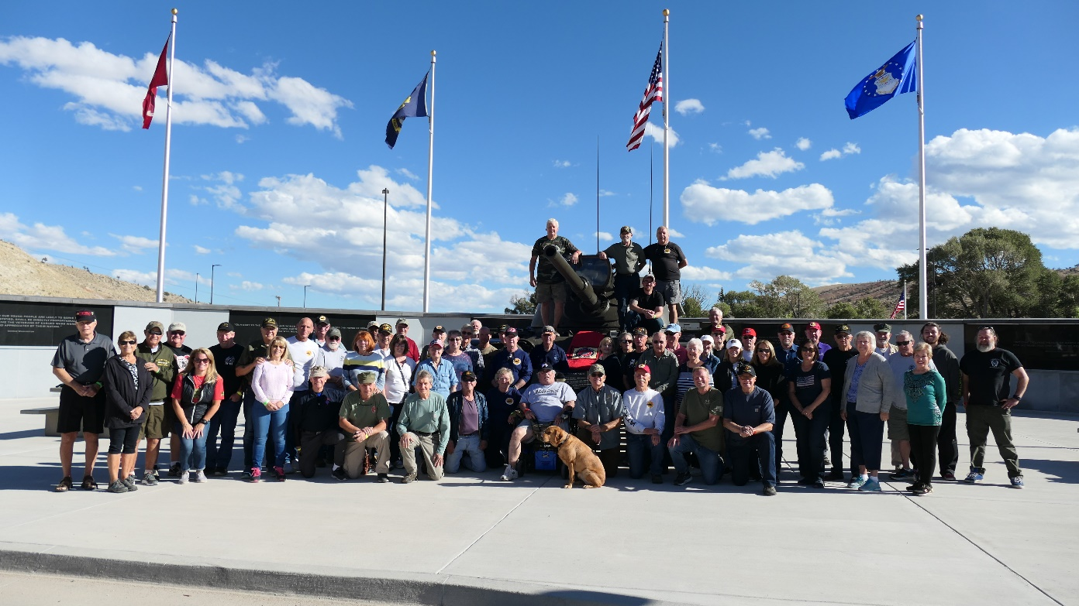
(a)
Wyoming Mini-Reunion Comments
Art Hines writes: Just wanted to thank you guys for the warm welcome at the reunion.
Everyone I met impressed me with their esprit de corps! You guys have an outstanding organization! We younger Marines always admired and looked up to you Vietnam Veterans. As an 81mm mortar man, it was very cool to hear stories of life in a M48. Hope to see everyone again in Colorado Springs. Semper Fi brothers,

MCTA President, Buster Diggs writes: First thank you for allowing me to attend your "mini reunion.” If you hadn't allowed me to come, I would've never seen a most amazing National Military Vehicle Museum that was just so special to me.
I'm giving you my address in hopes you will attach the reunion group photo to me. I will make a 7 X 10 to show the MCTA membership. Even better, I will shoot a copy to Sean, our newsletter editor to perhaps insert into our newsletter. I don't think the MCTA will ever be visiting due to our pledge that our reunions would always be easy to get to. You have got to admit, one had to WANT to go to Lander. No rush and will wait until you have a chance to shoot me a mail. It was nice at a mini reunion that we had the time to finally get to know one another better.

Glen Hoopman: My wife and I had a blast in Wyoming with the 'Nam Tankers. Everything went well and we really enjoyed how the owner, Dan Starks treated the vets! I told him that I considered him a veteran for everything he has done for those that served! He seemed grateful.

Adrian Knox (son of Clyde Knox): Thanks for everything. The trip exceeded our expectations. It was very special to me - to have my dad drive me around in a tank. Very cool…

Tuyen: I am thinking that we want two and three images per row…
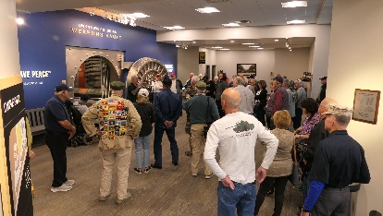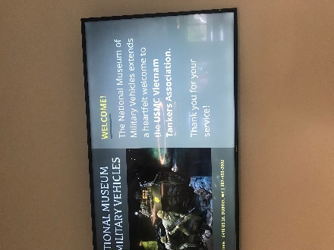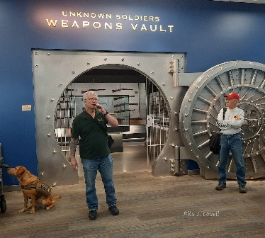
(b) (c) (d)

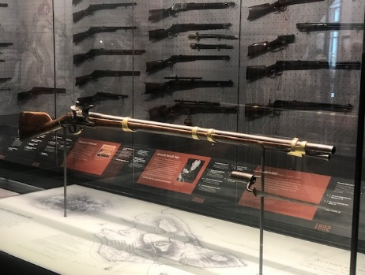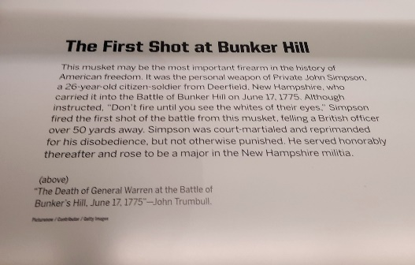
(zz) (ZZZ)

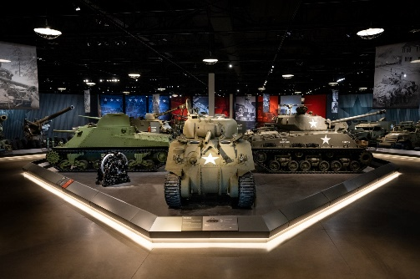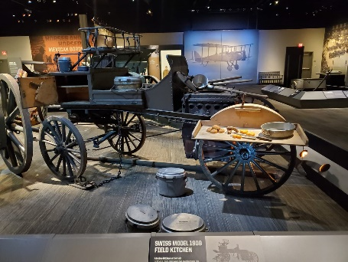
(e) (f)
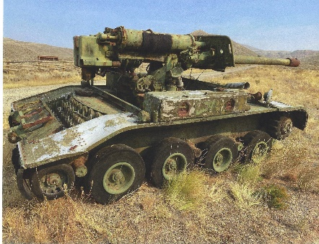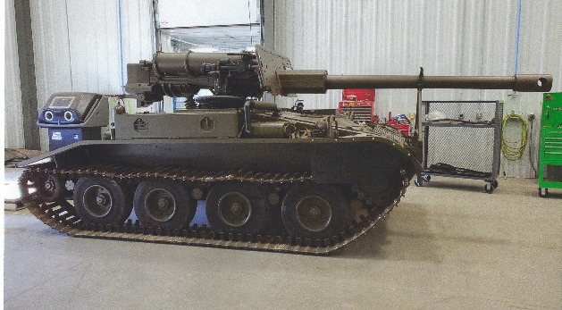
(g) (h)
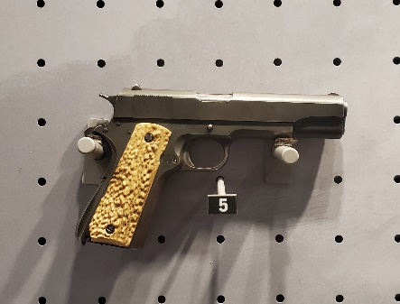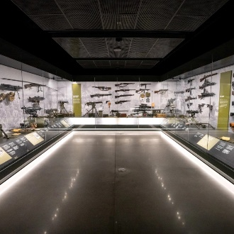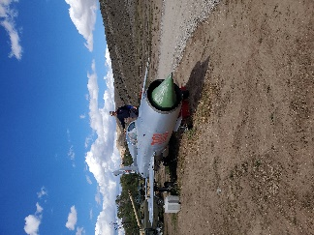
- (j) (k)
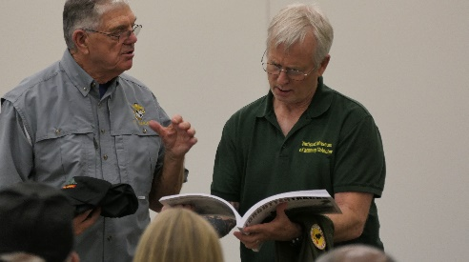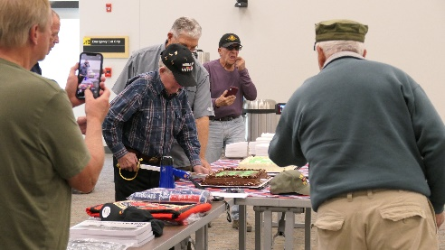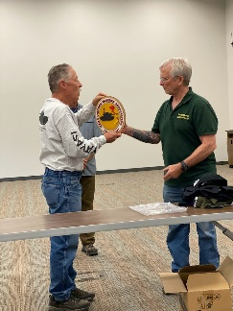
(l) (m) (n)
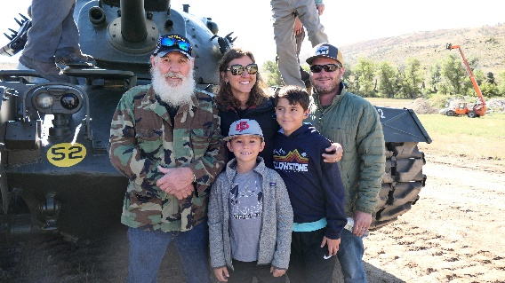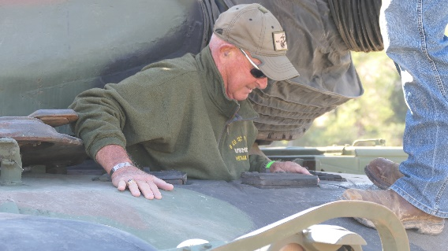
(o) (p)
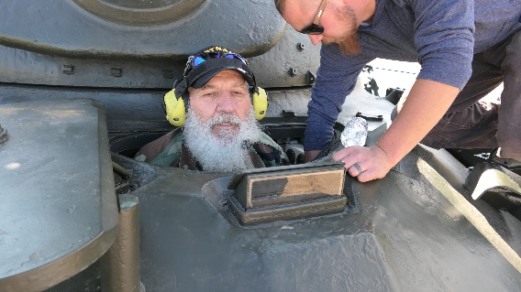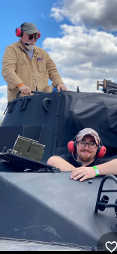
(q) (r)
Tuyen: If you want to make photo (r) twice as tall as the other photos, please do.

