KANSAS CITY 2026

USMC VTA 2026 MINI-REUNION
September 10 – 13, 2026
Homewood Suites KC International Airport
7312 NW Polo Drive | Kansas City, MO 64153
Phone: 816-880-9880

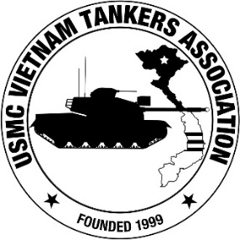

Please Print All

Name: ______________________________________________________

Guest’s Name (s): ____________________________________________

Address: ___________________________________________________

Town: State Zip Code _________________________________________

Cell Phone / Home Phone: _____________________________________

E-mail Address: ______________________________________________

Would you like to participate in our video interview program? Yes ___ No ___

Your USMC VTA membership dues must be current in order to attend the reunion. If your membership is delinquent, please mail your dues with this completed registration form (or the dues will be collected at the sign-in desk). No partial payments of the registration fee are accepted. Fee covers the one planned food function, bus transportation, meeting facilities, hospitality room, beer & sodas and other expenses associated with the cost of hosting the reunion. Registration fee does not include your sleeping room, taxes or air fare.

Please note that this is a mini-reunion for three days. We will not be conducting any special events other than visiting the National World War One museum and catering a BBQ dinner at the hotel. All other meals will be on your own.

To cover the bus transportation, the one dinner and the Slopchute beverages, please pay: $75 per person. Mail completed form and your reunion registration check to:

USMC VTA
c/o Ron Knight
6665 Burnt Hickory Drive
Hoschton, GA 30548–8280

